CS 255 System Design Document Template

This template lays out all the different sections that you need to complete for Project Two. Each section has guidance to prompt your thinking. You will need to continually reference the interview transcript as you work to make sure that you are addressing your client’s needs. There is no required length for the final document. Instead the goal is to complete each section based on what your client’s needs are. Remove this note when you are finished, and replace all bracketed text with the relevant information.

UML Diagrams

UML Use Case Diagram
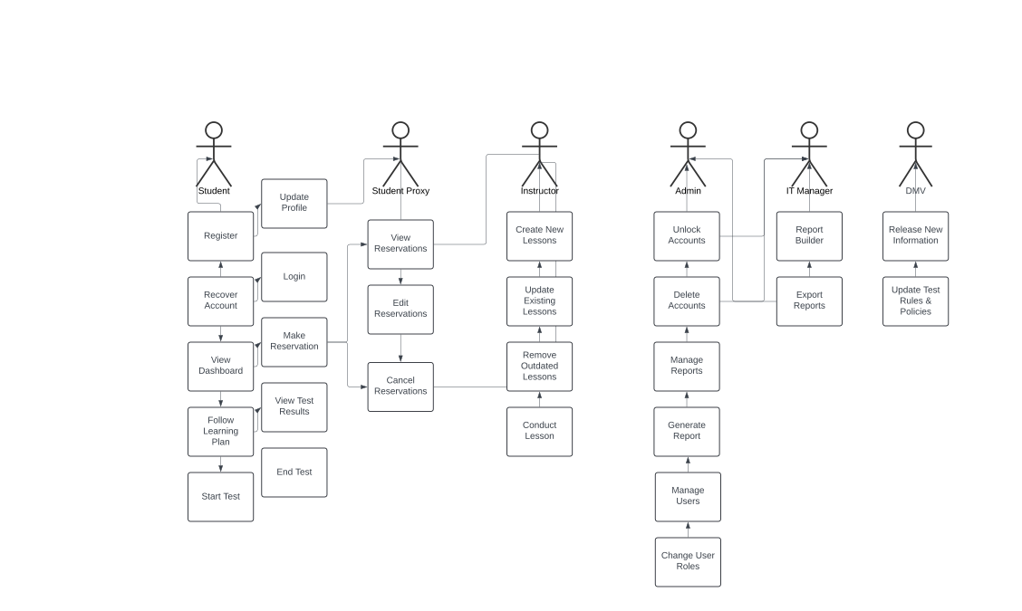

UML Activity Diagrams
The use cases to be demonstrated will an (Activity Diagram) to showcase the method for a user logging in.
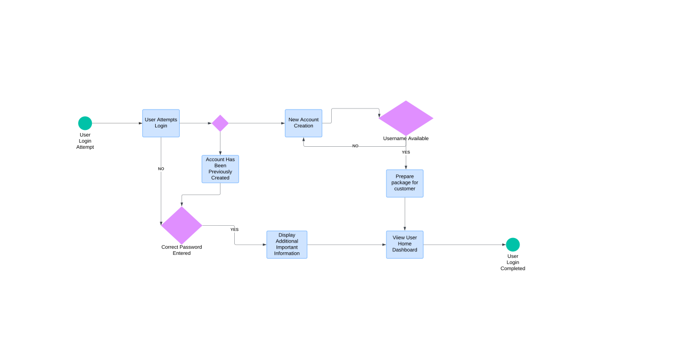

The method for reserving a driving test with the DMV.
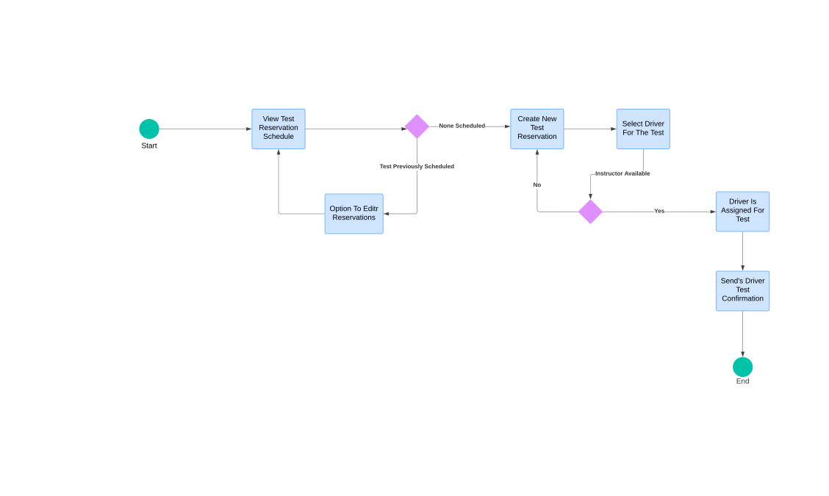

UML Sequence Diagram
This sequence depicts the workflow of a user attempting to login.
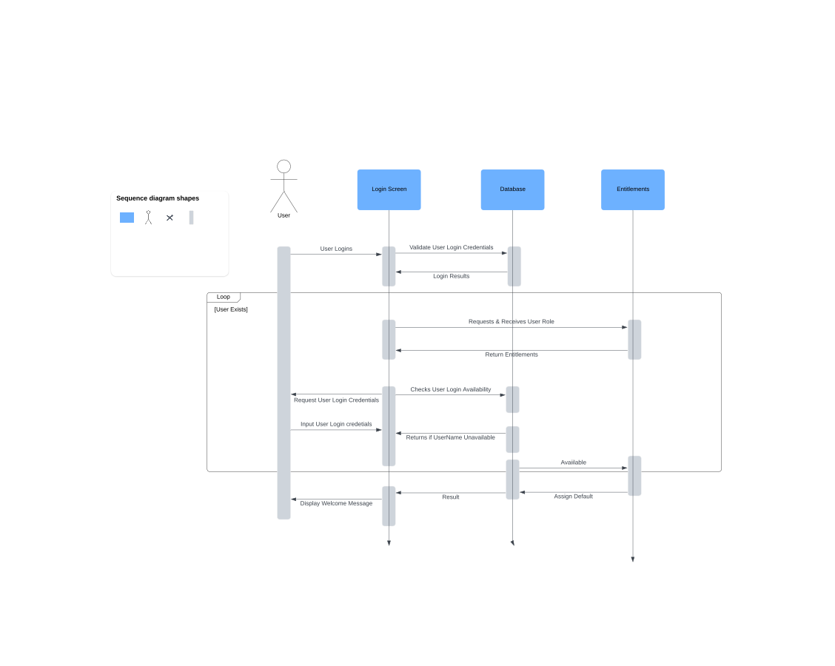

UML Class Diagram
The classes to be used are as follows:
- Classes Student & User
- Vehicle
- Reservation
- Instruction
- Test & Lesson
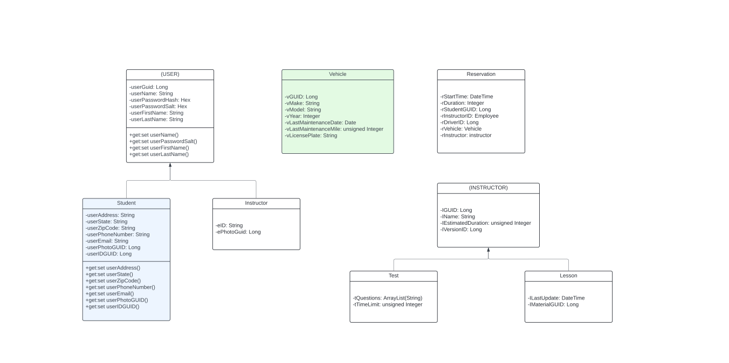

Technical Requirements
The technical requirements that will be needed for a web-based, LMS are listed below:

- A linux-based web server that employs IAAS to a variety of 3rd party hosting sites such as AWS, Cloudflare, or Google.
- These hosting sites allow for the LMS to have a scalable-architecture, similar to Docker employing Kubernetes.
- All APIs shall be designed to use RESTful techniques.
- The LMS needs to employ the SCORM standard.
- The LMS needs to make use of a hybrid approach. This should include the use RSA-encrypted AES-public keys for the encryption.
- All router traffic will need to be encrypted using TSL 1.2 standards or higher.
- The LMS needs to be tested out amongst various operating platforms. Current options are to include the majority used mobile OS. Latest versions would be the iOS 18 & Android 15.
- All uptimes shall have a KPI which will be no less than 99.5%.
- Reports shall be exported out using CSV-type formats.

